**Red Hat Integration Solution Self-Assessment Guide**

**Introduction**

Integration Delivery Services team is utilising Red Hat Integration Solution to deliver for agile distributed integration architecture. Together we will access the viability of this product to meet your business requirement.

**Description**

Red Hat® Integration is a comprehensive set of integration and messaging technologies to connect applications and data across hybrid infrastructures. It is an agile, distributed, containerized, and API-centric solution. It provides service composition and orchestration, application connectivity and data transformation, real-time message streaming, change data capture, and API management—all combined with a cloud-native platform and toolchain to support the full spectrum of modern application development.

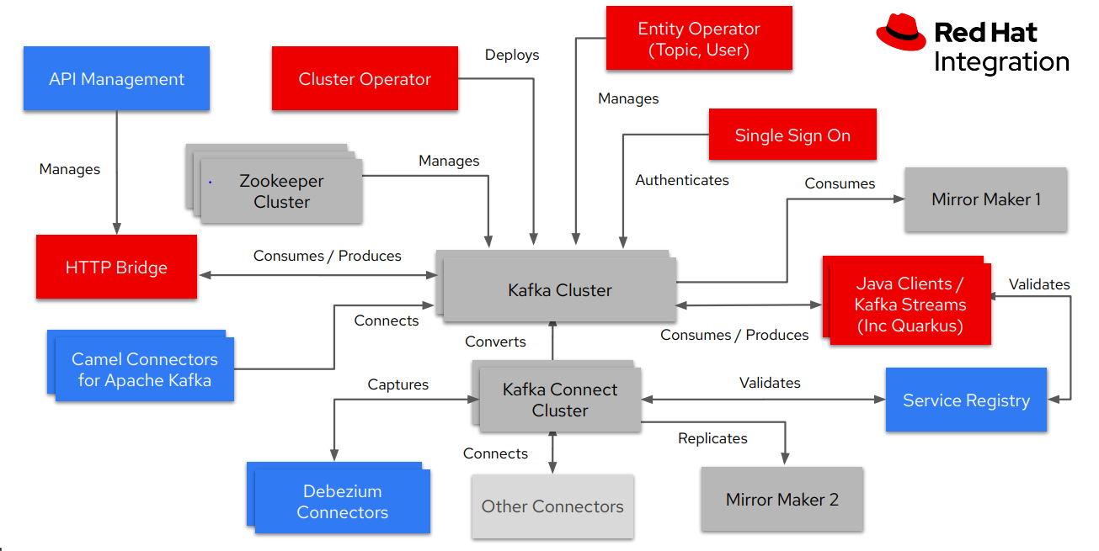

* Grey boxes represent open source Apache Kafka code base
* Red boxes represent the automation and management capabilities provided through Red Hat AMQ Streams
* Blue boxes represent other capabilities (API management, distributed ESB, data change capture, etc) provided through the rest of Red Hat Integration Suite

**Self Assessment**

Red Hat Integration is made up of Red Hat Runtimes, Red Hat Fuse, Red Hat 3 scale API Management, Red Hat AMQ, Change data capture and Service Registry. Please review example reasons for using each products in the table below to see if any of the use cases apply to your requirements. We recommend this to review this assessment guide in consultation with your solution team.

|  |  |  |
| --- | --- | --- |
| **Product** | **Description** | **Example Reasons to Use This** |
| Red Hat Runtimes | A set of products, tools, and components for developing and maintaining cloud-native applications. It offers lightweight runtimes and frameworks for highly distributed cloud architectures, such as microservices. [Learn more](https://www.redhat.com/en/products/runtimes) | * You are developing a microservice-based integration solution * You are looking to run on supported (by Red Hat and by ISB Integration Delivery Services team) container images * You are looking to set up a guaranteed delivery channel (using Red Hat AMQ Broker (Apache ActiveMQ)) |
| Red Hat Fuse | A distributed, cloud-native integration solution—based on open source technologies like Apache Camel—that enables users to utilize a range of design patterns and connectors, and choose their own programming language and deployment preferences - including on-prem, in public/private clouds, or as a hosted service. [Learn more](https://www.redhat.com/en/technologies/jboss-middleware/fuse) | * You are looking to set up a container based microservice integration solution that empowers application developers to continuously innovate. Developers can deploy services, APIs, and integrations independently to support your applications. |
| Red Hat AMQ | A fast, lightweight, flexible, and secure messaging platform—based on open source technologies including Apache ActiveMQ and Apache Kafka—enabling reliable delivery and real-time integration. [Learn more](https://www.redhat.com/en/technologies/jboss-middleware/amq-old) | * You are looking to establish reliable delivery (eg. message queues) / real-time integration (eg. event publishing) between two or more applications. * Using various messaging patterns to support real-time messaging, Red Hat AMQ integrates applications, endpoints, and devices quickly and efficiently. As a result, your application will be more responsive and agile. |
| Change data capture | A distributed solution, based on open source technologies like Debezium, to stream changes from database. | * You are looking to automatically generate business events from your application's database changes (rather than modifying your existing application code) * Change data capture (CDC) can help your business make faster, data-driven decisions to reduce wasted time, effort, and revenue. * CDC helps companies maximize the value of data by enabling them to leverage the information for multiple purposes. By providing a method to consistently update the same data in various siloes, CDC allows the organization to get the most out of the data while preserving data integrity. * CDC allows multiple databases and applications to stay in sync with the latest data, giving business stakeholders the most up-to-date information without changing application code. |
| Service registry | A service registry is a database for the storage of data structures for application-level communication. It serves as a central location where app developers can register and find the schemas used for particular apps.  A contract between publisher and subscriber for streaming as well as synchronous traffic, providing more data governance and fewer errors. | * You can use a service registry to decouple the structure of your data from your applications and to share and manage your data structures and API descriptions at runtime using a REST interface. * A service registry validates the schema and detects errors in the data to ensure data integrity. The service registry can include rules to ensure that uploaded content is syntactically and semantically valid and is backward and forward compatible with other versions. * Detecting data-related errors early in the development lifecycle, rather than at runtime, saves on the higher costs of development time incurred when fixing errors downstream in the process. |
| Red Hat 3scale API Management | An infrastructure platform on which to share, secure distribute, control, and monetize APIs. [Learn more](https://www.redhat.com/en/technologies/jboss-middleware/3scale) | * This product is not currently available for the sector. * This part of toolkit is under evaluation by the Integration Delivery Services team. |

**Next Steps**

If the use cases highlighted above address one or more of your integration requirements you should reach out to the Integration Delivery Services team and see what they can enable within your project to solve your integration needs using the Red Hat Integration Suite.